 VINOD SIR’S GROUP TUTION

MARKS: 40 IX-MATHS-I-PRELIUM TIME: 2 HOURS

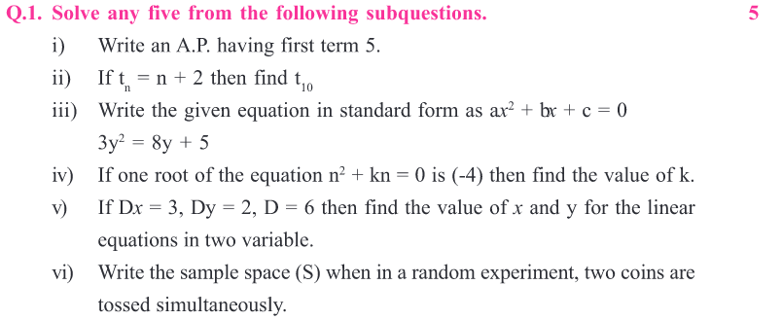

Q. 2. (A) Choose the correct alternative: (4)

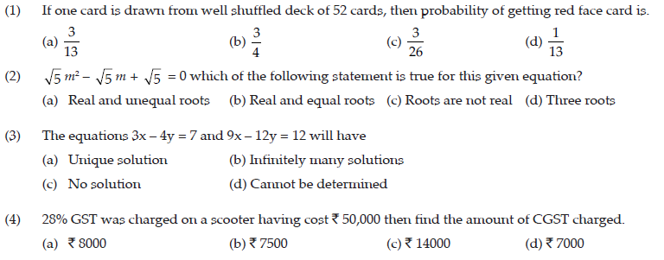

Q. 2. (B) Solve the following: (Any 2) (4)

(1) Find the 25th term of A.P 12, 16, 20, 24, .......
(2) Obtain the quadratic equation if roots are –3, –7
(3) The record of a weather station shows that out of the past 250 consecutive days, if weather forecasts were correct 175 times. What is the probability that on a given day it was correct?
Q.3. (A) Complete the following activities: (Any 2) (4)

(1) If x = 5 is the root of a equation Kx2 – 14x – 5 = 0, then find the value of K by completing the following activity?
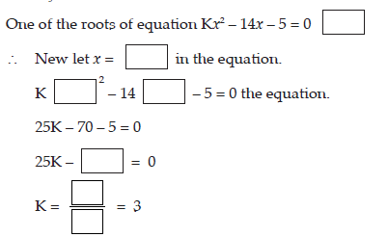

(2) Form a Road safety committee of two from 2 boys (B1, B2) and 2 girls (G1, G2).

(3) Complete the following activity to write the sample space.
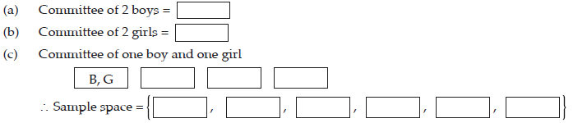

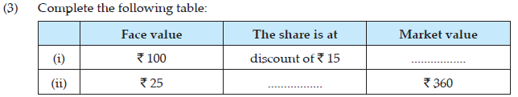

Q. 3. (B) Solve the following questions: (Any 2) (4)
(1) The sum of two roots of a quadratic equation is 5 and sum of their cubes is 35. Find the equation.
(2) Prashant bought 50 shares of FV ` 100 having MV ` 180. Company gave 40% dividend on the shares. Find the rate of return on investment.
(3) Medical check-up of 180 women was conducted in a health centre in a village. 50 of them were short of haemoglobin, 10 suffered from cataract and 25 had respiratory disorders. The remaining women were healthy. Show the information in a pie chart.

Q.4. Solve the following questions: (Any 3) (9)

(1) Fifty seeds were selected at random from each of 5 bags of seeds, and were kept under standardized conditions favourable to germination. After 20 days, the number of seeds which had geminated in each collection were conducted and recorded as follows
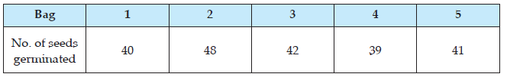
What is the probability of germination of
(i) More than 40 seeds in a bag.
(ii) 49 seeds in a bag
(iii) More than 35 seeds in a bag

(2) Solve 5x – 6y + 30 = 0 and 5x + 4y – 20 = 0 graphically.

(3) A trader from Surat, Gujarat sold cotton clothes to a trader in Rajkot, Gujarat. The taxable value of cotton clothes is ` 2.5 lacs. What is the amount of GST at 5% paid by the trader in Rajkot.
(4) Find the sum of all odd numbers from 1 to 150.

Q.5. Solve the following: (Any 1) (4)

(1) If the sum of first p terms of an A.P is equal to the sum of the first q terms, then show that the sum of its first (p + q) terms is zero.

(2) M/s. Jay Chemicals purchased a liquid soap for ` 8000 (with GST) and sold it to the consumers for ` 10,000 (with GST). Rate of GST is 18%. Find the amount of CGST and SGST to be paid by Jay chemicals.

Q.6. Solve the following questions: (Any 1) (3)

(1) The sum of father's age and twice the age of his son is 70. If we double the age of the father and add it to the age of his son the sum is 95. Find their present ages.
(2) Grouped frequency distribution of supply of milk to hotels and the number of hotels is given in the following table. Find the mode of the supply of milk.

